**LAB MANUAL**

**Chapter 6 | ARTIFICIAL INTELLEGENCE**

**Lab – 24**



**Power BI installation**

**Power BI installation**

**Objective:**

The objective of this lab is to utilize ChatGPT to generate Python code that creates an animation of an elastic ball dropping from a height and bouncing when it touches the ground using the Pygame library. Additionally, this lab aims to demonstrate how to execute the generated code to visualize the animation.

**Equipment Required:**

The following list provides the minimum requirements to run Power BI Desktop:

**Important**

* Power BI Desktop is no longer supported on Windows 7.
* Windows 8.1 or Windows Server 2012 R2 or later.
* .NET 4.7.2 or later.
* Microsoft Edge browser (Internet Explorer is no longer supported)
* Memory (RAM): At least 2 GB available, 4 GB or more recommended.
* Display: At least 1440x900 or 1600x900 (16:9) required. Lower resolutions such as 1024x768 or 1280x800 aren't supported because some controls (such as closing the startup screens) display beyond those resolutions.
* Windows display settings: If you set your display to change the size of text, apps, and other items to more than 100%, you won't see some dialogs that you must interact with to continue using Power BI Desktop. If you encounter this issue, check your display settings in Windows by going to Settings > System > Display, and use the slider to return display settings to 100%.
* CPU: 1 gigahertz (GHz) 64-bit (x64) processor or better recommended.
* WebView2: If WebView2 wasn't automatically installed with Power BI Desktop or if it was uninstalled, [download and run the installer for WebView2](https://go.microsoft.com/fwlink/p/?LinkId=2124703).

**Note**

We recommend using a client version of Windows, such as Windows 10, instead of Windows Server. Power BI Desktop doesn't support Internet Explorer Enhanced Security Configuration because it will stop Power BI Desktop from signing in to the Power BI service.

**Prerequisites:**

1. Internet skill to access the Power BI site
2. Computer OS skill to install the software

**Problem Statement:**

To Install the power BI for handling the data.

**Install as an app from**

1. Use one of the following options to open the **Power BI Desktop** page of the Microsoft Store:

* Open a browser and go directly to the [Power BI Desktop page](https://aka.ms/pbidesktopstore) of the Microsoft Store.
* From the [Power BI service](https://learn.microsoft.com/en-us/power-bi/fundamentals/service-get-started), in the upper right corner, select the **Download** icon and then choose **Power BI Desktop**.

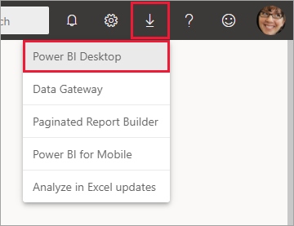

* Go to the [Power BI Desktop product page](https://powerbi.microsoft.com/desktop/), and then select **Download Free**.

1. After you've landed on the **Power BI Desktop** page of the Microsoft Store, select **Install**.

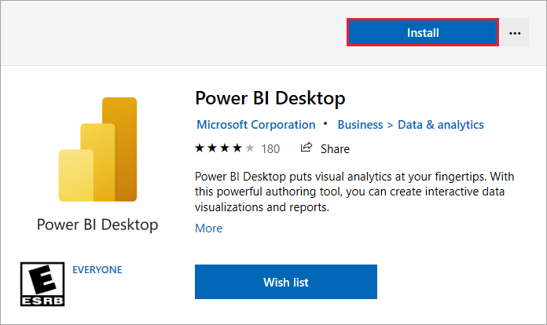

There are a few advantages to getting Power BI Desktop from the Microsoft Store:

* **Automatic updates**: Windows downloads the latest version automatically in the background as soon as it's available, so your version is always up to date.
* **Smaller downloads**: Microsoft Store ensures only components that changed in each update are downloaded to your computer, resulting in smaller downloads for each update.
* **Admin privilege isn't required**: When you download the package directly and install it, you must be an administrator for the installation to complete successfully. If you get Power BI Desktop from the Microsoft Store, admin privilege isn't required.
* **IT roll-out enabled**: Through the Microsoft Store for Business, you can more easily deploy, or *roll out*, Power BI Desktop to everyone in your organization.
* **Language detection**: The Microsoft Store version includes all supported languages, and checks the language used on your computer each time it's launched. This language support also affects the localization of models created in Power BI Desktop. For example, built-in date hierarchies match the language that Power BI Desktop uses when the *.pbix* file is created.

The following considerations and limitations apply when you install Power BI Desktop from the Microsoft Store:

* If you use the SAP connector, you might need to move your SAP driver files to the *Windows\System32* folder.
* Installing Power BI Desktop from the Microsoft Store doesn't copy user settings from the *.exe* version. You might have to reconnect to your recent data sources and reenter your credentials.

**Note**

The Power BI Report Server version of Power BI Desktop is a separate and different installation from the versions discussed in this article. For information about the Report Server version of Power BI Desktop, see [**Create a Power BI report for Power BI Report Server**](https://learn.microsoft.com/en-us/power-bi/report-server/quickstart-create-powerbi-report).

**Download Power BI Desktop directly**

To download the Power BI Desktop executable from the Download Center, select **Download** from the [Download Center page](https://www.microsoft.com/download/details.aspx?id=58494). Then specify the 32-bit or 64-bit installation file to download.

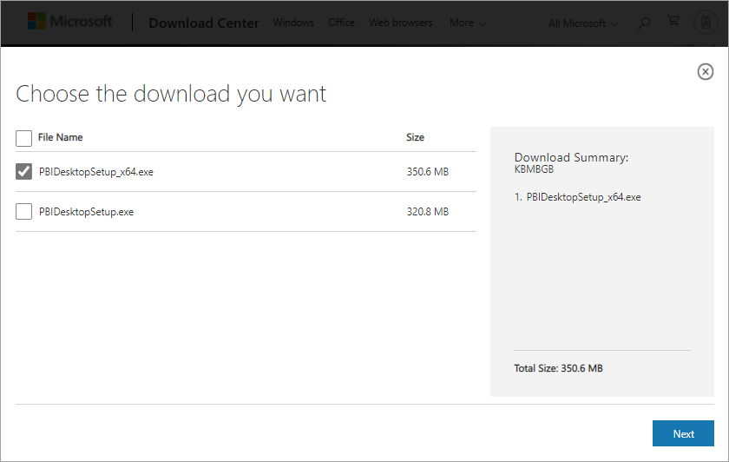

**Install Power BI Desktop after download**

You're prompted to run the installation file after you finish downloading it.

Power BI Desktop ships as a single *.exe* installation package that contains all supported languages, with separate *.exe* files for the 32-bit and 64-bit versions. The *.msi* packages are no longer available. You need the executable for installation. This approach makes distribution, updates, and installation easier and more convenient, especially for administrators. You can also use command-line parameters to customize the installation process, as described in [Using command-line options during installation](https://learn.microsoft.com/en-us/power-bi/fundamentals/desktop-get-the-desktop#use-command-line-options-during-installation).

After you launch the installation package, Power BI Desktop installs as an application and runs on your desktop.

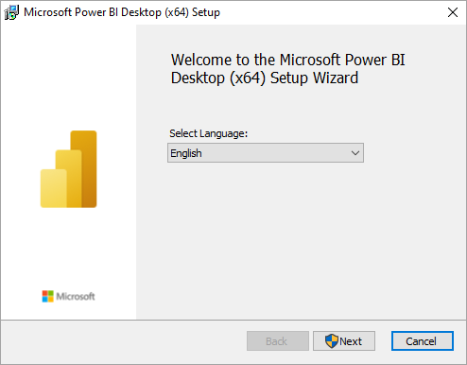

**Note**

Installing the deprecated *msi* version and the Microsoft Store version of Power BI Desktop on the same computer. Sometimes referred to as a *side-by-side* installation isn't supported. Manually uninstall Power BI Desktop before you download it from the Microsoft Store.

**Use Power BI Desktop**

When you launch Power BI Desktop, a welcome screen appears.

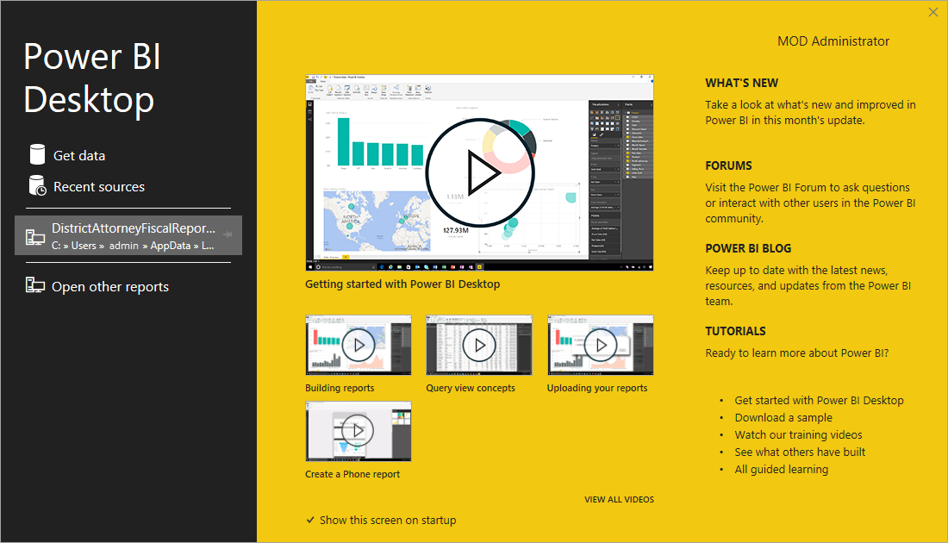

When you launch Power BI Desktop for the first time, if the installation isn't an upgrade, you're prompted to fill out a form or sign in to the Power BI service before you can continue.

After that, you can begin creating data models or reports, and share them with others on the Power BI service. Check out the [Next steps](https://learn.microsoft.com/en-us/power-bi/fundamentals/desktop-get-the-desktop#next-steps) section for links to guides to help you get started using Power BI Desktop.